**Team ID :** LTVIP2025TMID22059

**Team Size :** 4

**Team Leader :** Kummara Vara Lakshmi

email id:- [Kchinni9900@gmail.com](mailto:Kchinni9900@gmail.com)

**Team member :** Peddakotla Naveen Kumar Reddy

email id:- [naveenkumar.pkd2005@gmail.com](mailto:naveenkumar.pkd2005@gmail.com)

**Team member :** Haritha Rayanki

email id:- [rayankiharithachowdary@gmail.com](mailto:rayankiharithachowdary@gmail.com)

**Team member :** B. Tarakanath Reddy

email id:- [bhumanapallitarakanathreddy646@gmail.com](mailto:bhumanapallitarakanathreddy646@gmail.com)

Project Title**:-Property Management Application using Salesforce**

**Project Overview:**

This project is focused on property management application using salesforce, designed to address the primary challenge of inefficient property management workflows and fragmented data. The goal is to deliver a comprehensive solution by leveraging salesforce service cloud, experience cloud, and custom lightning web components. through this project, we aim to enhance operational efficiency, improve tenant experience, and ensure data accuracy and support the long-term goals of the property management department and overall business growth.

**Objectives:-**

• Business Goals:

1. Reduce tenant service request resolution time by 25% within 6 months.

2. Increase tenant satisfaction scores by 15% within 1 year.

3. Improve property maintenance scheduling efficiency by 30% within 3 months.

4. Increase the number of properties with customer names in the report, amounting to properties, within the next quarter.

• Specific Outcomes:

1. Implement a tenant portal for self-service requests and communication.

2. Develop a centralized property management dashboard in Salesforce.

3. Automate property maintenance scheduling and work order management.

4. Integrate with existing property management systems for data synchronization.

5. Create a report of properties with customer names.

### Salesforce Key Features and Concepts Utilized

**Objects**:

objects are database tables that store specific types of information. There are two main types: Standard Objects (like Accounts, Contacts, and Opportunities) and Custom Objects (created by users for specific needs).

**Tabs:**

tabs are user interface elements that provide quick access to different types of data or functionality within the system. Tabs allow users to view and interact with objects like Accounts, Contacts, Opportunities, or custom objects.

**The lightning app:**

A Lightning App in Salesforce is a custom application built using the Lightning Experience framework. It helps users work efficiently by combining objects, pages, and components into a single interface.

**Fields:**

Fields are data storage units that hold specific information in a record, like a name, date, or number. They help organize and store details in a structured way.

**Field dependency:**

Field dependency is a relationship where the value of one field controls the available options in another field. It helps in filtering and organizing data based on user selections.

**Relationship:**

Relationships define how data is connected between different objects. They help link records to show related information.

**Page layout:**

Page Layout controls how fields, buttons, and sections are arranged on a record page. It helps customize the user interface for better data entry and visibility.

**Record type:**

Record Types allow different layouts, picklist values, and processes for the same object. They help customize data entry based on user roles or business needs.

**Reports:**

Reports are structured summaries of data presented in tables or charts. They help analyze, filter, and display information based on specific criteria.

**Dashboard:**

A Dashboard is a visual representation of multiple reports using charts, graphs, and metrics. It helps users quickly analyze data and track key performance indicators.

**Detailed Steps to Solution Design**

**Objects:**

**Create a new custom objects:**

Custom objects -enquiry,property,loan.

**CREATEA ENQUIRY OBJECT:**

In Custom object defining page:

1.Enter the label name (Enquiry )

2. plural label name (Enquiries )

3. Record name (Customer Name).

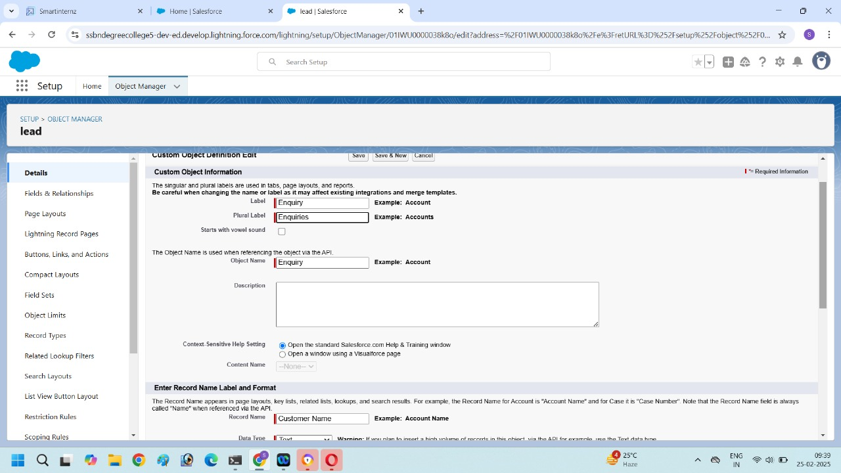

4.Click allow reports and save.

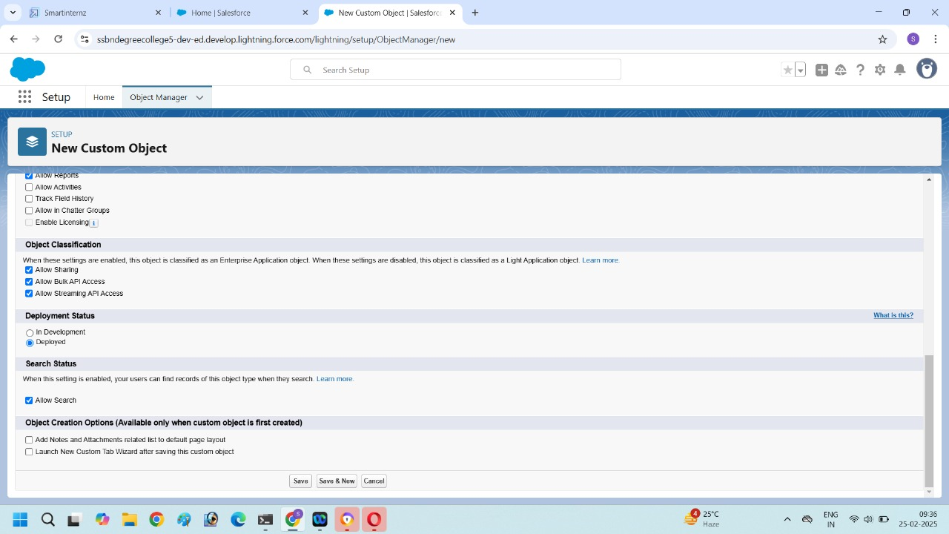

Create property and loan objects are same as we already created enquiry object**.**

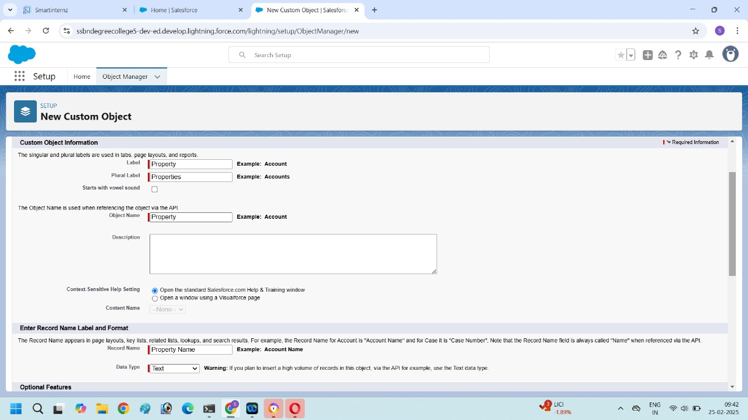

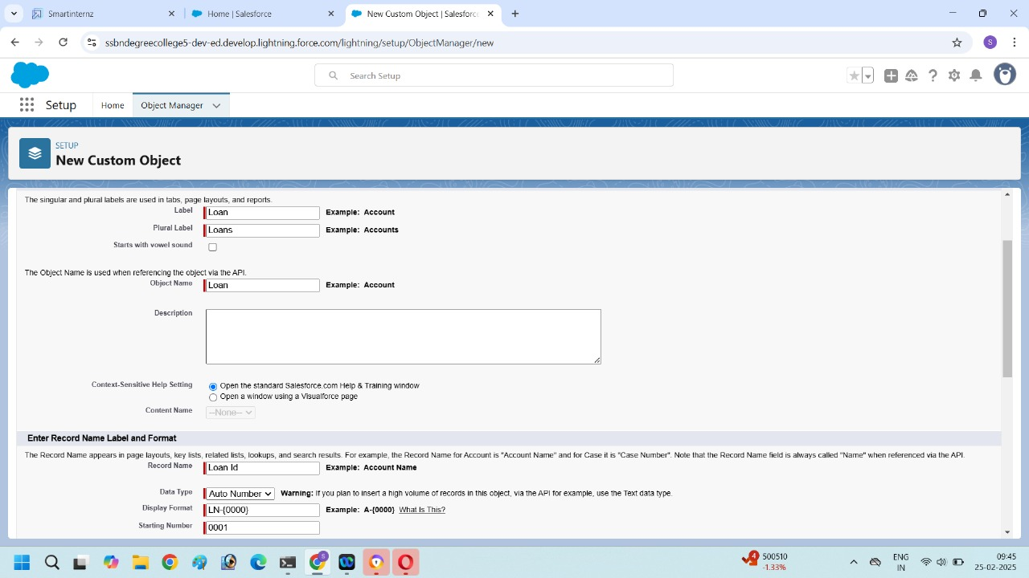

**Create a Tab for (Enquiry, property, loan):**

1. Search "Tabs" in the Quick Find box and select Tabs.

2. Under Custom Object Tabs, click New.

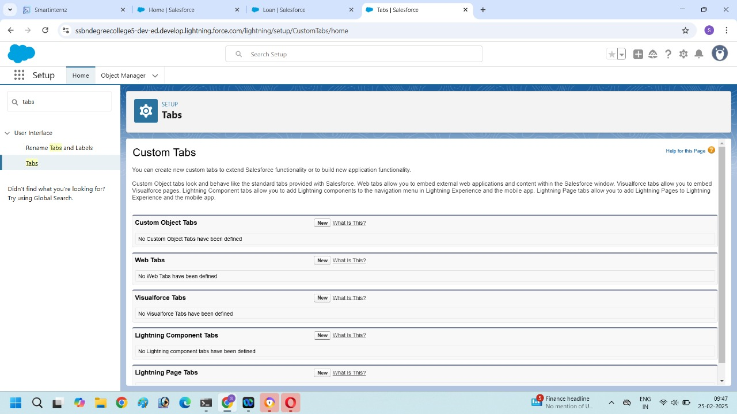

3. Select Enquiry from the object dropdown.

4. Choose a Tab Style (icon and color).

5. Click Next, set Tab Visibility, and click Next again.

6. Add it to the required apps.

7. Click Save.

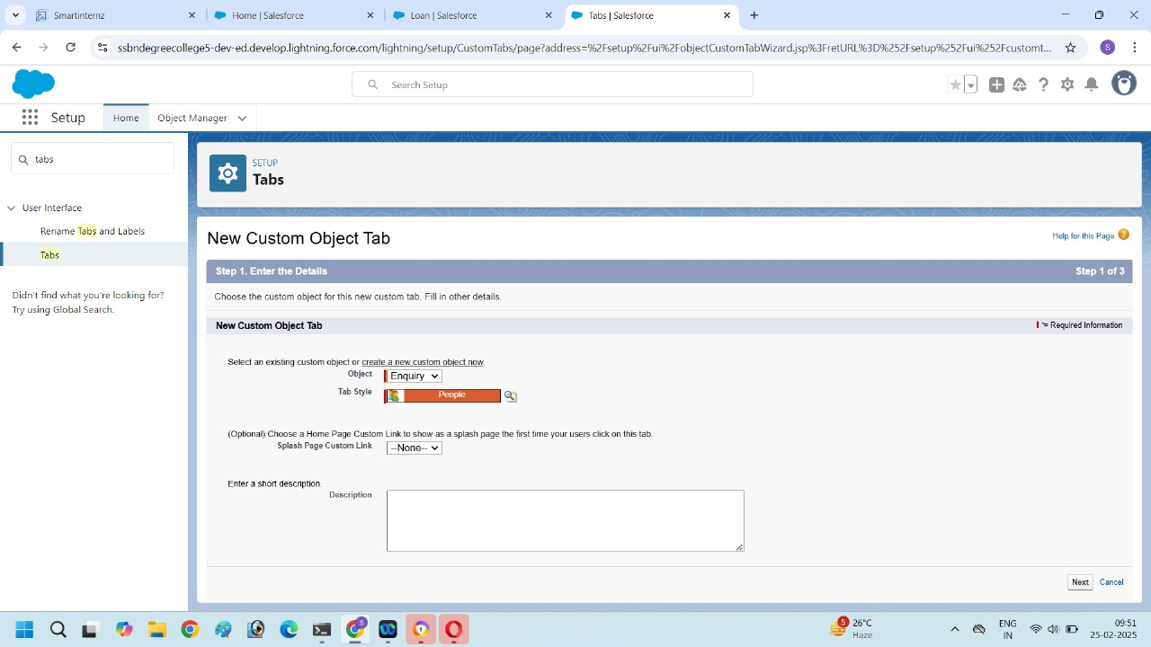

Create Tab for the Property and Loans.

**The Lightning App:**

1.Select “app manager” in quick find.

2.Click new lightning app.

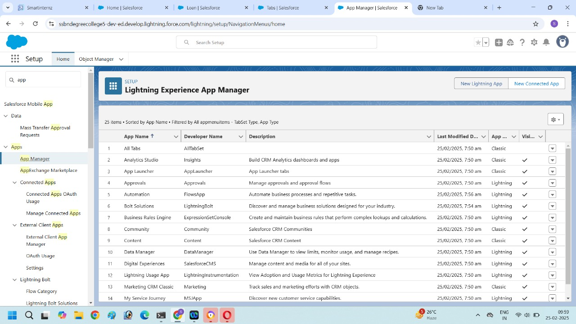

3.Enter the name as Project Management in app.

4.Fill all the details then click next.

5.Add Navigation items:

(Enquiry, Property, Loans, Report, Dashboard) select the items from the search bar and moving it using the arrow button then click next.

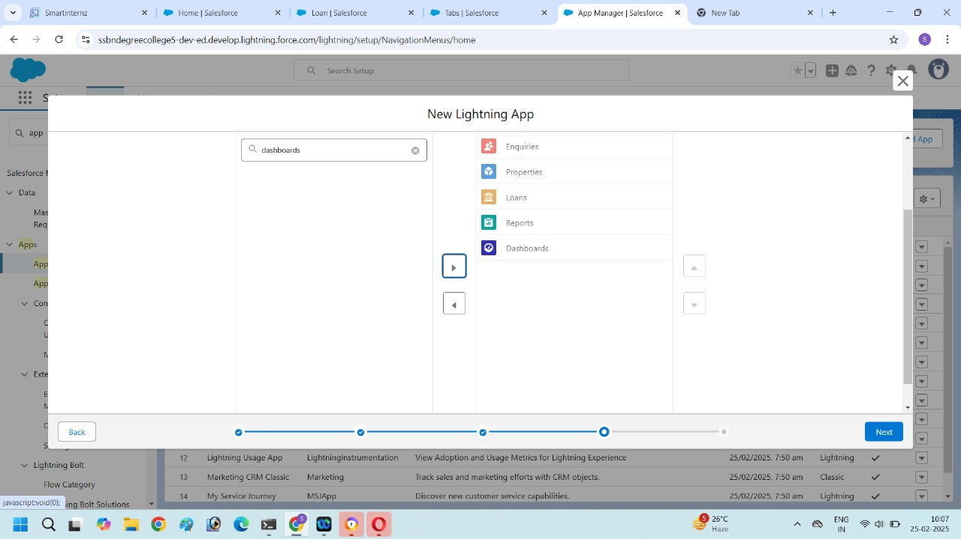

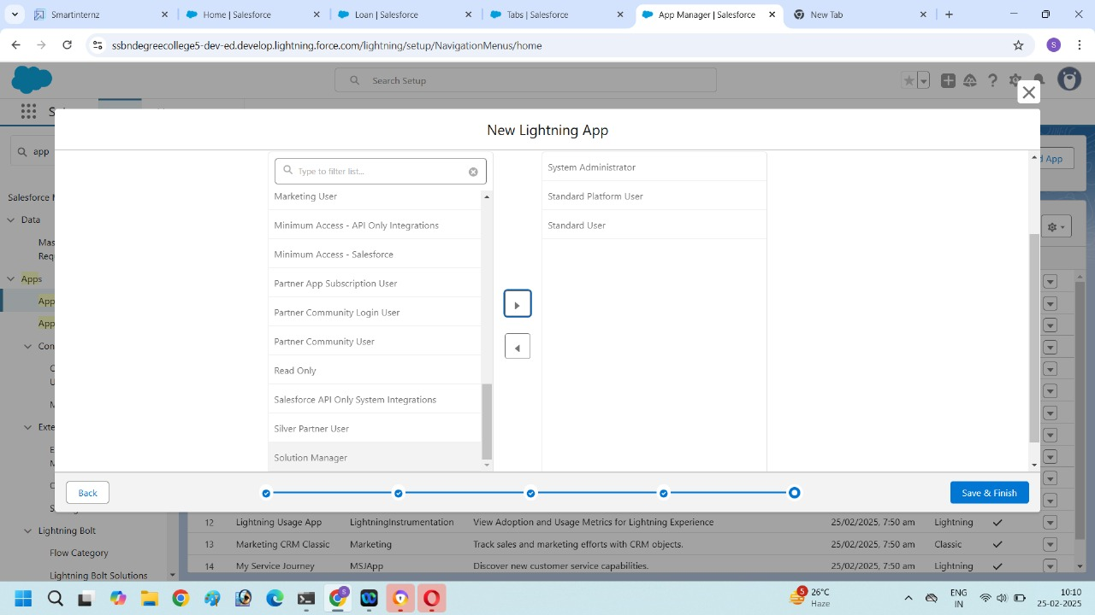

6.To add user profiles:

(Administrator, salesforce platform user, standard user)

7.Search profiles in search bar, click the arrow button, then save and finish.

**Fields :**

1.Go to setup, click object manager.

2.Type object name “Enquiry” in search bar and click on the that object.

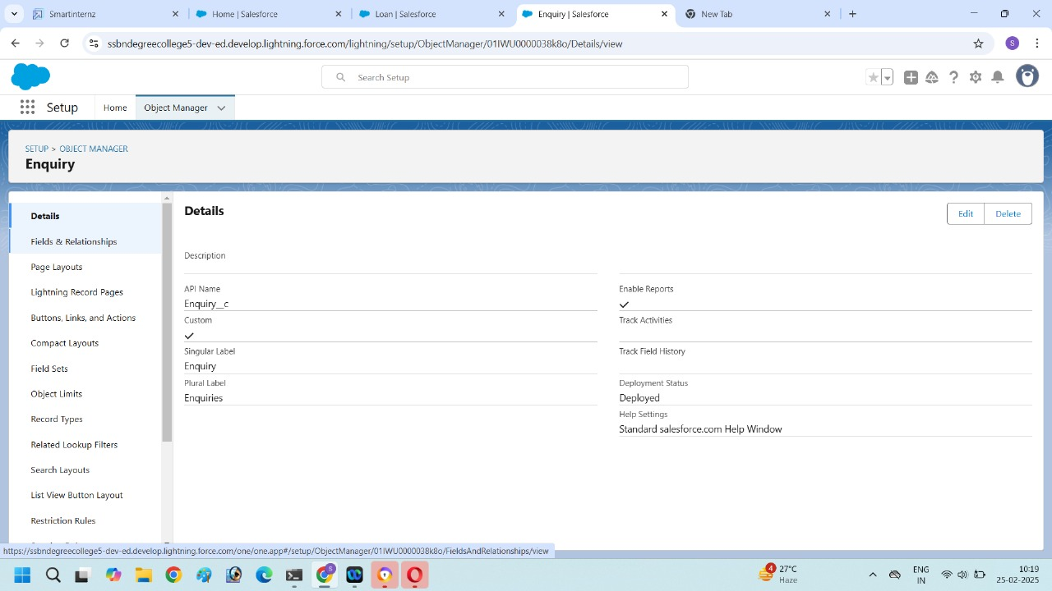

3.Next click on “Fields and Relationship” and then click New.

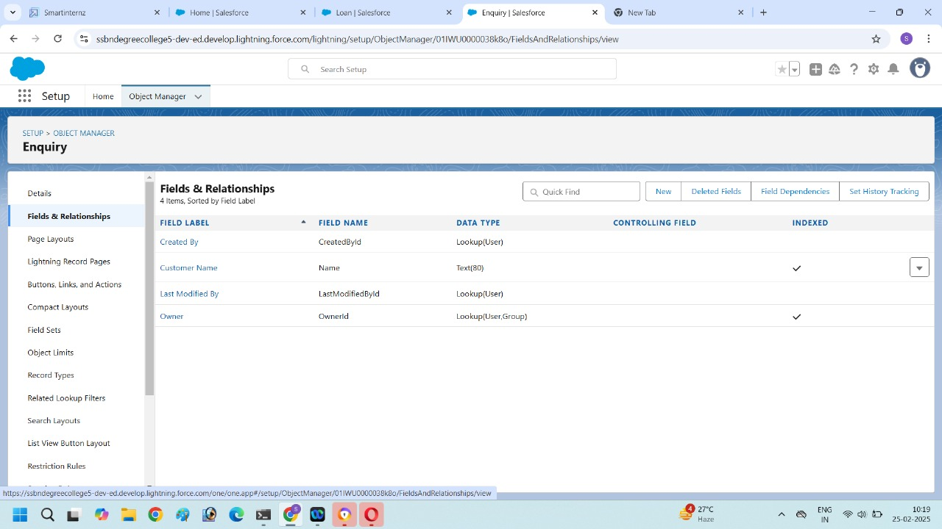

4. Select Data type (Auto Number).

5.Fill the Name as Lead number, and display format.

6.Click next and save.

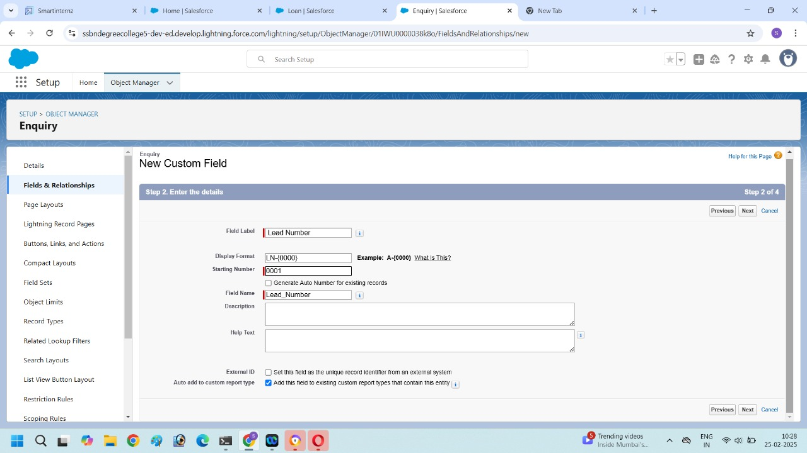

**Create another Field:**

1.Click the object manager and select the Enquiry object.

2.Next click on “Fields and Relationship, next click new.

3.Select the Data type as Picklist.

4.Enter the label as Lead type. And enter picklist values BUY ,RENT.

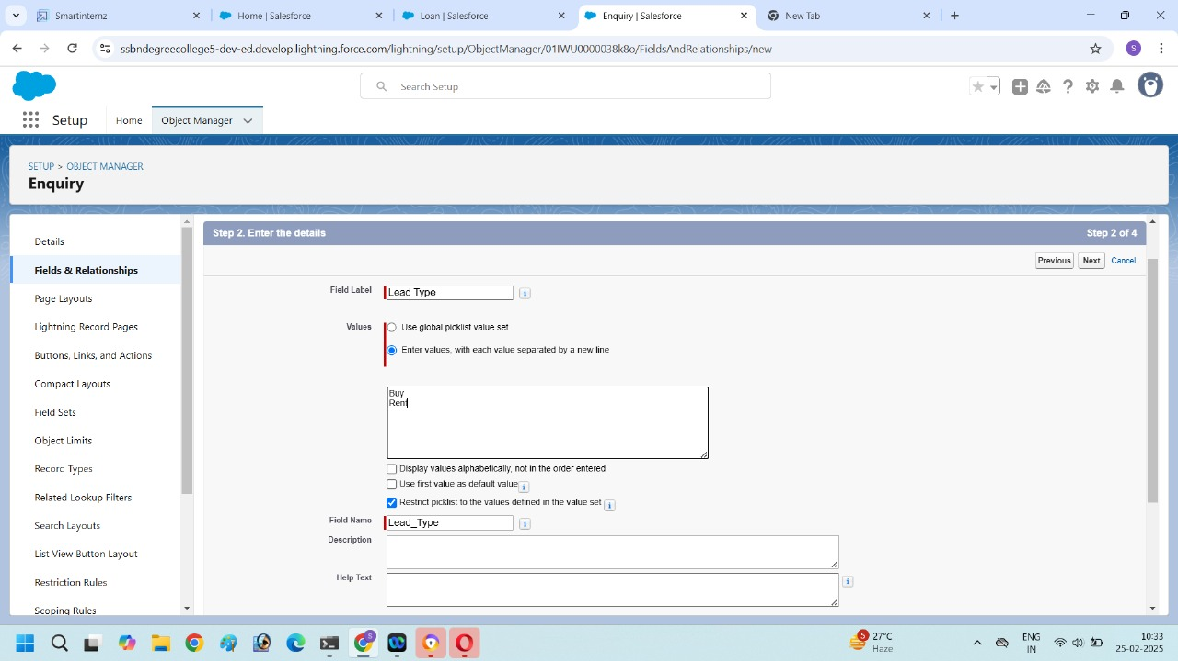

5.Click next and save.

**Create another Field in Enquiry Object :**

1.Go to setup, click object manager.

2.Type object name “Enquiry” in search bar and click on the that object.

3.Next click on “Fields and Relationship, next click new.

4.Select the Data type as Picklist.

5.Enter the Field label as State and then enter picklist values are

(Maharashtra , Gujarat, Rajasthan)

6.Click next and save.

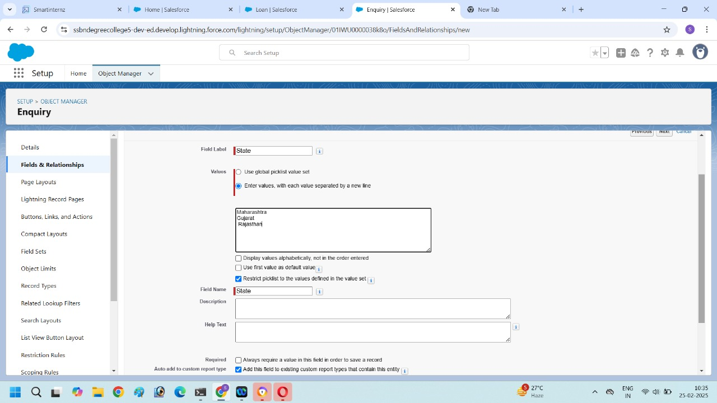

**Create another Field in Enquiry object**:

1.Go to setup, click object manager.

2.Type object name “Enquiry” in search bar and click on the that object.

3.Next click on “Fields and Relationship, next click new.

4.Select the Data type as Phone.

5.Enter the Field label is phone then click next and save.

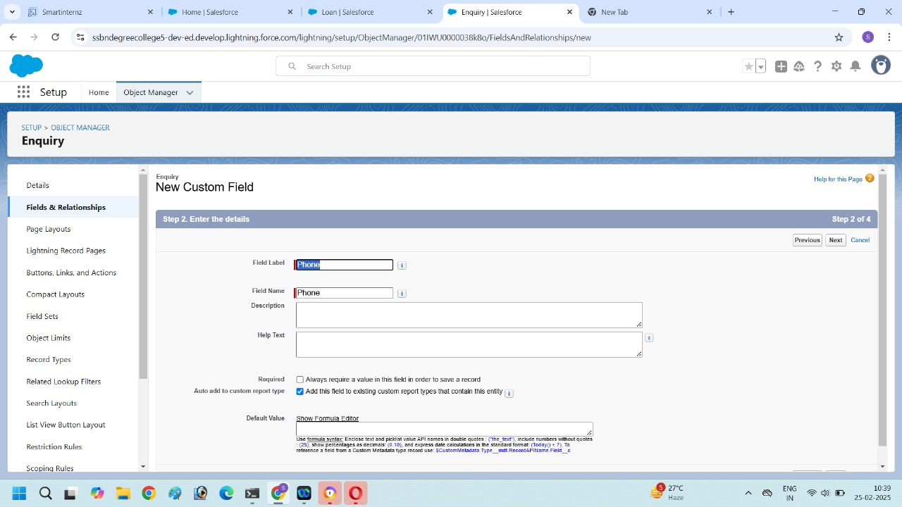

**These are the Fields created in ENQUIRY object :**

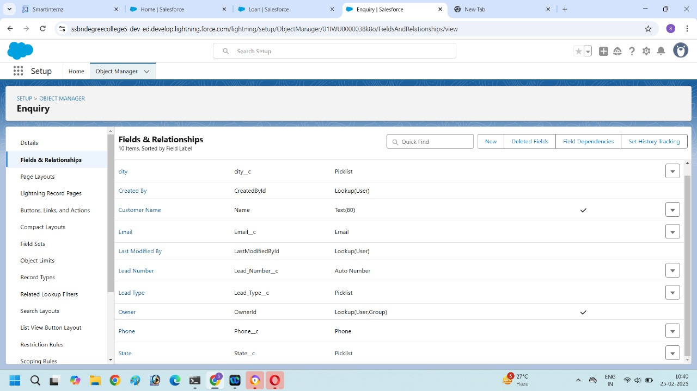

**Field Dependency:**

1.Select Enquiry object in object manager then click on that object.

2.Click Fields and Relationship and click Field dependency.

3.Click new.

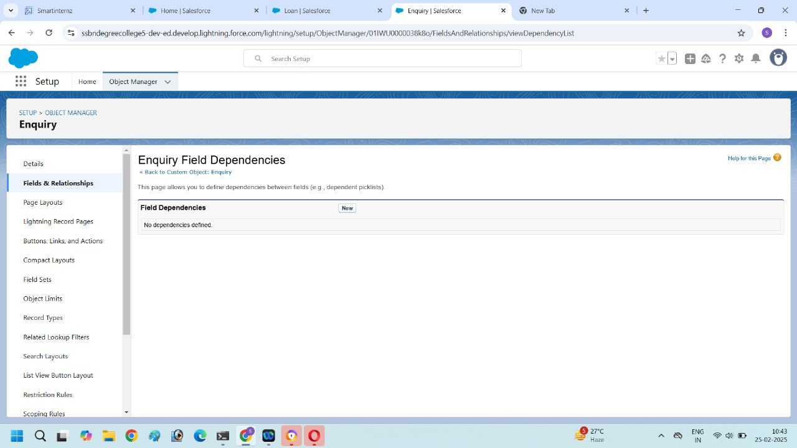

4.Select state as the Controlling field and select City as the Dependent field, And then click continue.

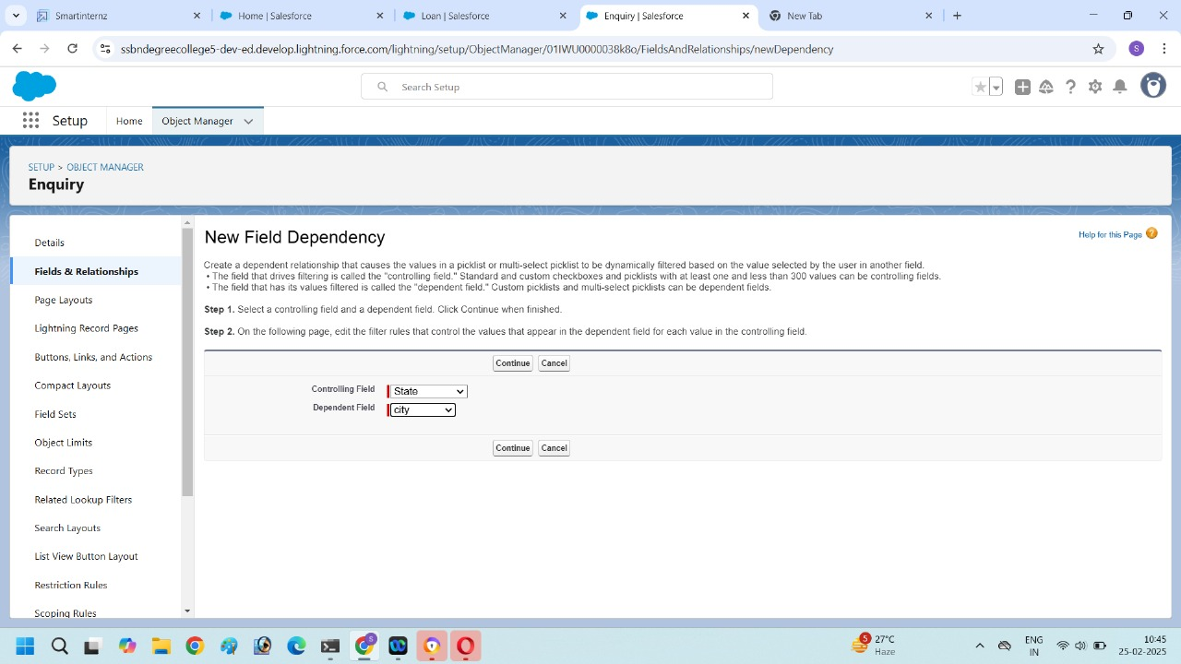

5.Selct the appropriate value in each column by double-clicking them.

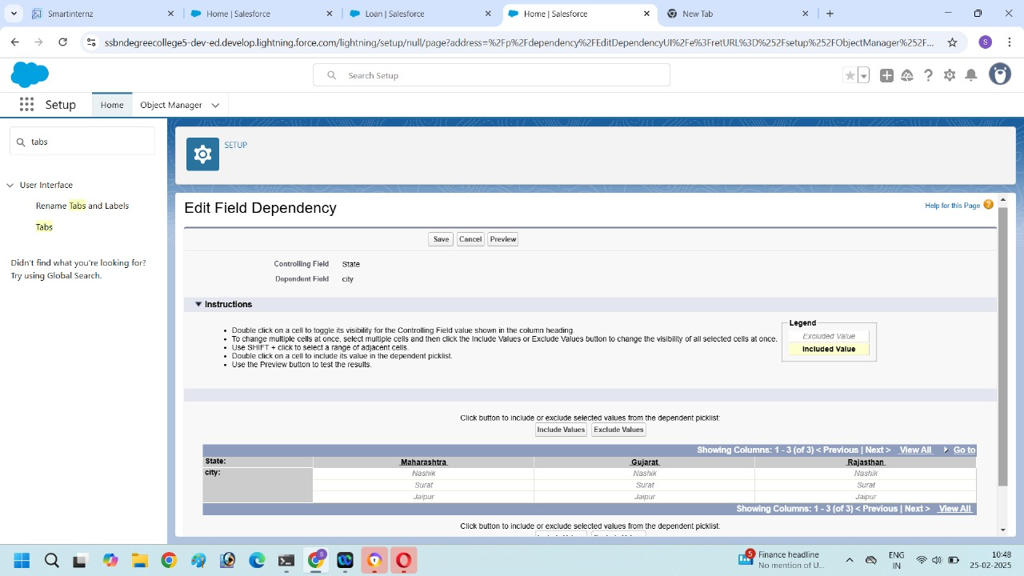

6.Click includes values. And it is same for Gujarat& Rajasthan with its city.

7.Click Preview, then test the dependency by selecting different state and viewing the associate values available for particular state.

8. Click close to the preview window and then click save.

**Create Fields in Property object:**

1.Go to setup, click object manager.

2.Type object name “Property” in search bar and click on the that object.

3.Next click on “Fields and Relationship, next click new.

4.Select the Data type as Lookup relationship.

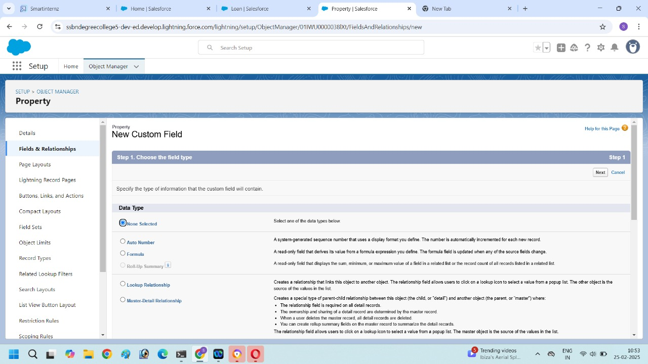

5.Enter the Field label Customer name and related to Enquiry.

6.Click next and save.

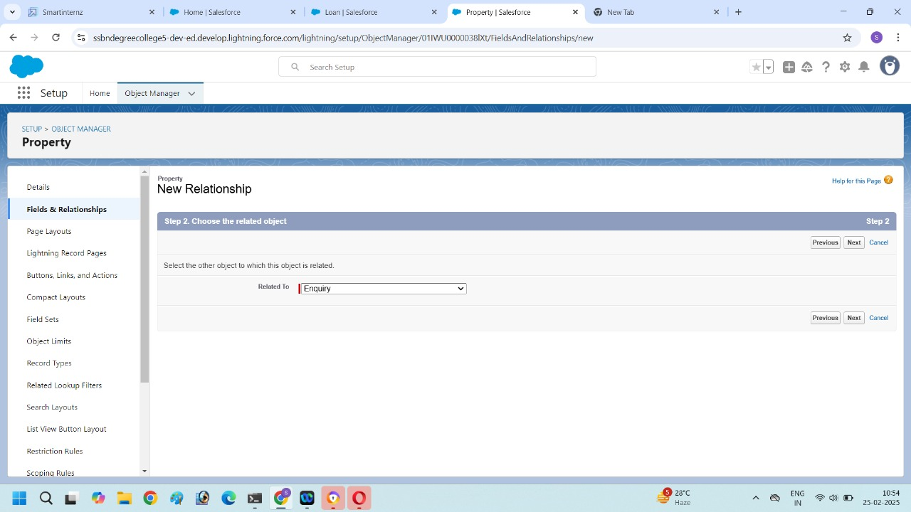

**Create Formula Field in Property object:**

1.Go to setup, click object manager.

2.Type object name “Property” in search bar and click on the that object.

3.Next click on “Fields and Relationship, next click new.

4.Select the Data type as Formula.

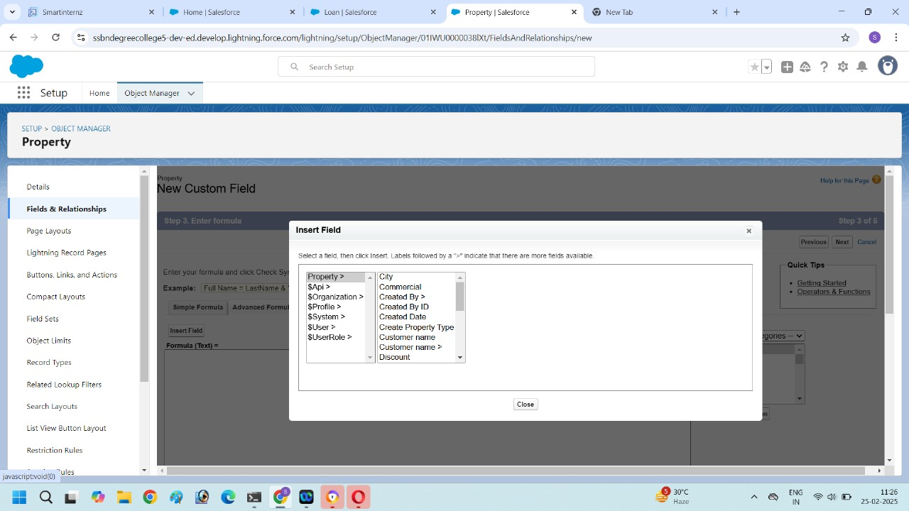

6.Click on the advance Formula, and insert the formula.

7.Check the formula syntax to know whether the formula is correct or error.

8.Click and save.

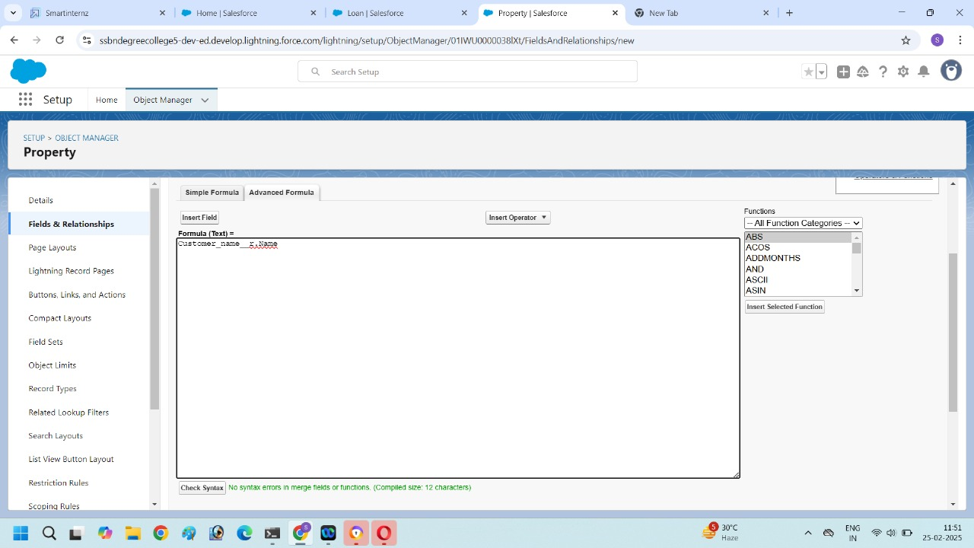

**Create Formula field in Loan:**

1.Go to setup, click object manager.

2.Type object name “Loan” in search bar and click on the that object.

3.Next click on “Fields and Relationship, next click new.

4.Select the Data type as Formula.

5.In formula option select Advanced formula and insert the field.

6. Check syntax and if formula is no errors then click save.



**Page layout:**

Create page layout for property object

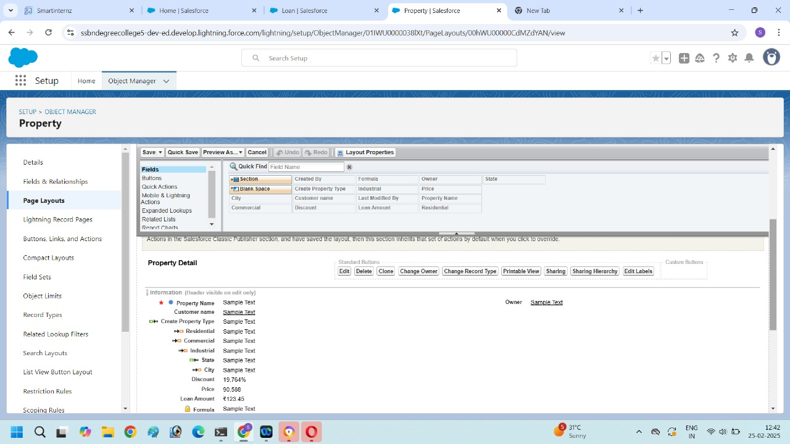

1.Click on the object manager and then type property object in search bar.

2.Click on Page layout and click New.

3.We can add or remove the page layout field with the help of drag and drop of fields.

**Record Type:**

Record type for property object

1.Click on the object manager and then type property object in search bar

2.Click on Record type and click New.

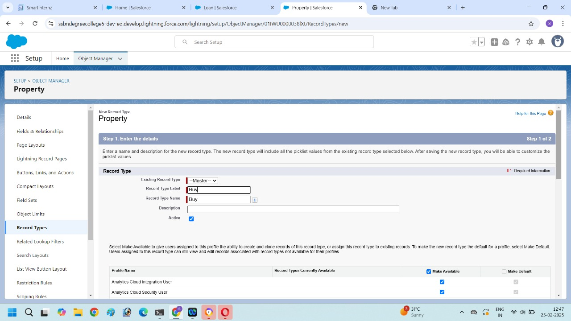

3.Enter the record type label as BUY and selective active checkbox next and save.

Create Record type for Rent as we created as record type of Buy.

**Testing and Validation:**

Our testing approach for Salesforce project management will focus on ensuring core functionalities operate as expected. We will use a combination of unit testing to validate individual components like custom fields and workflows, system testing to simulate end-to-end project lifecycles, and user acceptance testing (UAT) to gather feedback from project managers. We will validate functional accuracy, performance, security, and usability. All test cases and identified defects will be tracked, and a final report will summarize the test results and acceptance status.

**PROFILES :**

Create a New profile

1.Search profiles in quick find box.

2.Click on the profiles clone on the desired profile(Standard user is preferable).

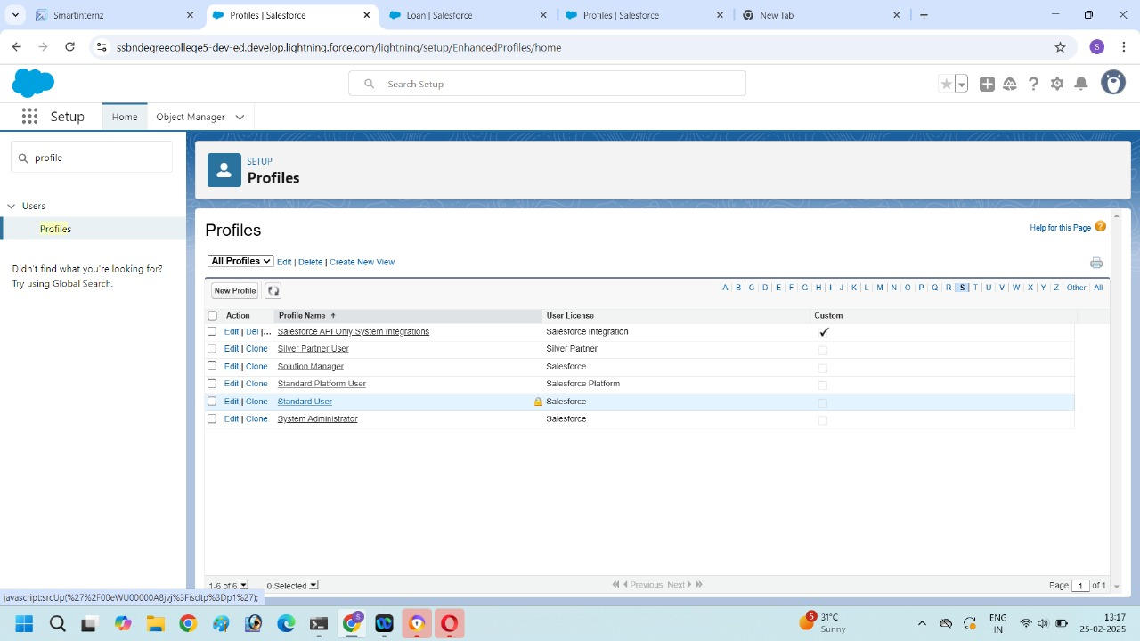

3.Enter a profile name (Sales Manager) and click on save.

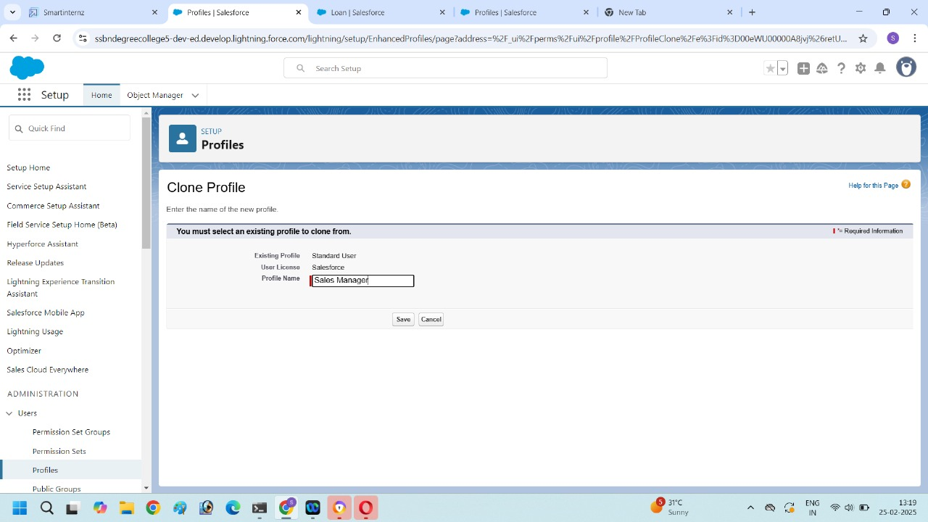

4.Click on the new created profile and then click edit option in that page.

5.Scroll down to custom object permission and give all permissions for Enquiry Property, Loan and save.

6.Sales Manager also having Create, Edit, Delete for Enquiry ,property and Loan objects.

**USERS :**

Create user

1.Search Users in quick find box and select users.

2.Then click new user.

3.Enter all the details like First name

Last name, Email, User name, Nick name, Role, User license, Profile and click save button.

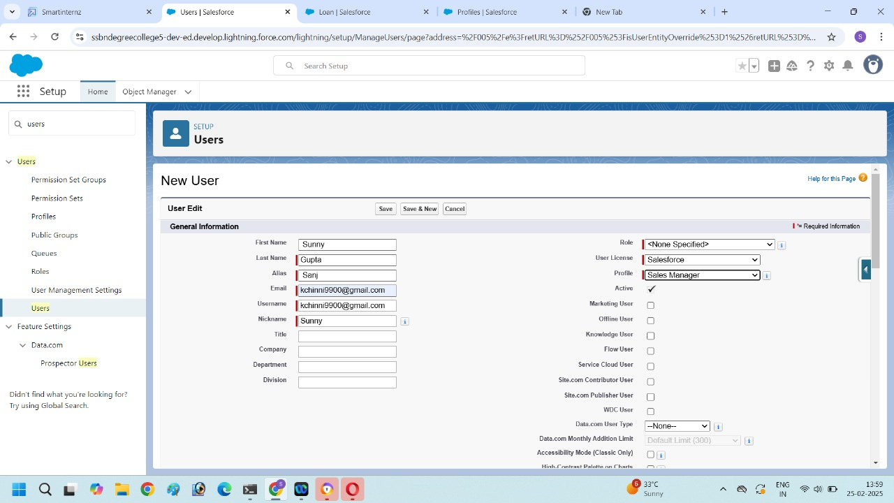

**Permission Set:**

1.Search permission set in quick find box then select it.

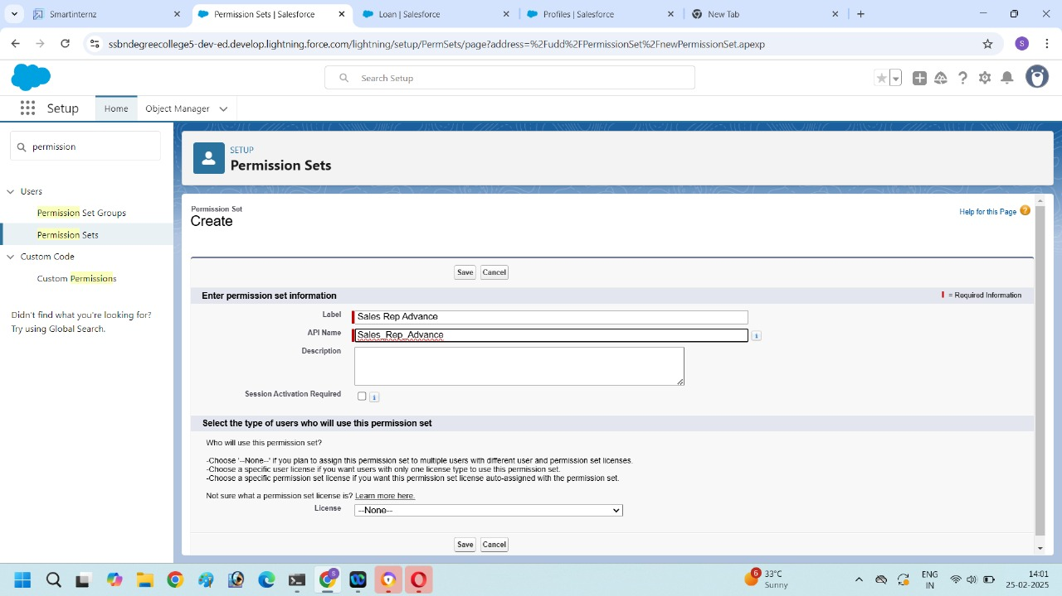

2.Click new.

3.Enter the label name as( sales Rep Advance) and save.

4.Select object settings and then search property object and click edit button.

5.In object permission we give all permission and click save button.

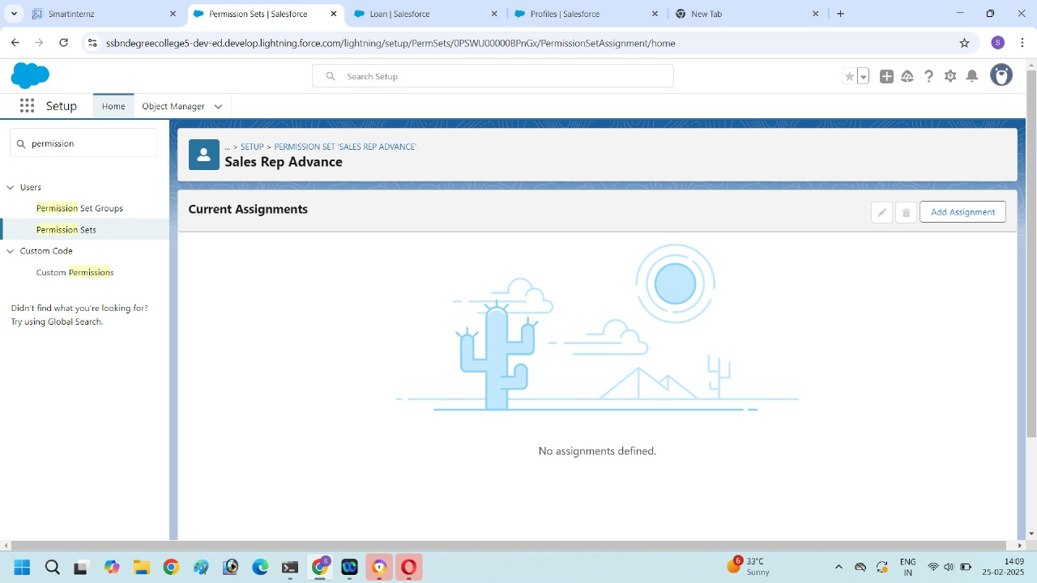

6.Next click on the Manage assignment, then click on the Add assignment.

7.Now select the user (sunny)and click next& assign.

**Set up for OWD:**

1.Search for sharing settings in quick find box and select it under Organization-wide Defaults then click edit.

2.For each object choose a sharing settings. Like private, public Read only, public read/write.

3.To disable automatic access using your hierarchies for Enquiry, Property and Loan.

4.Click edit in the last and select private for internal and external.

5.This setting is for all the user which have been created.

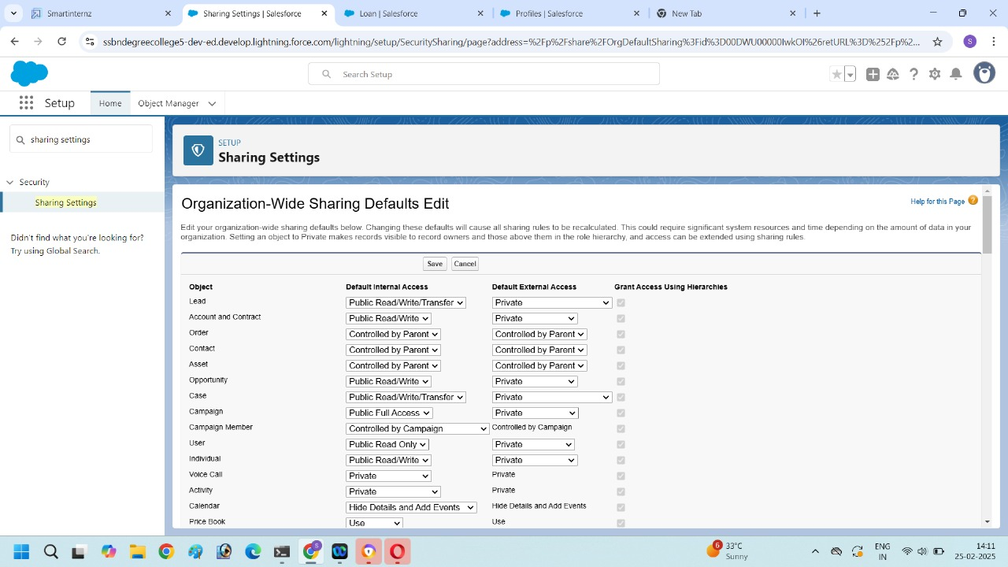

**Reports:**

1.Click on the app launcher and select Reports then click new Report.

2.Select the Property object and fill the details then click continue.

3.Add filters to the property object.

4. Add Summaries like Total then click add charts next save and run.

5.Enter a Report name and select folder and description then click save.

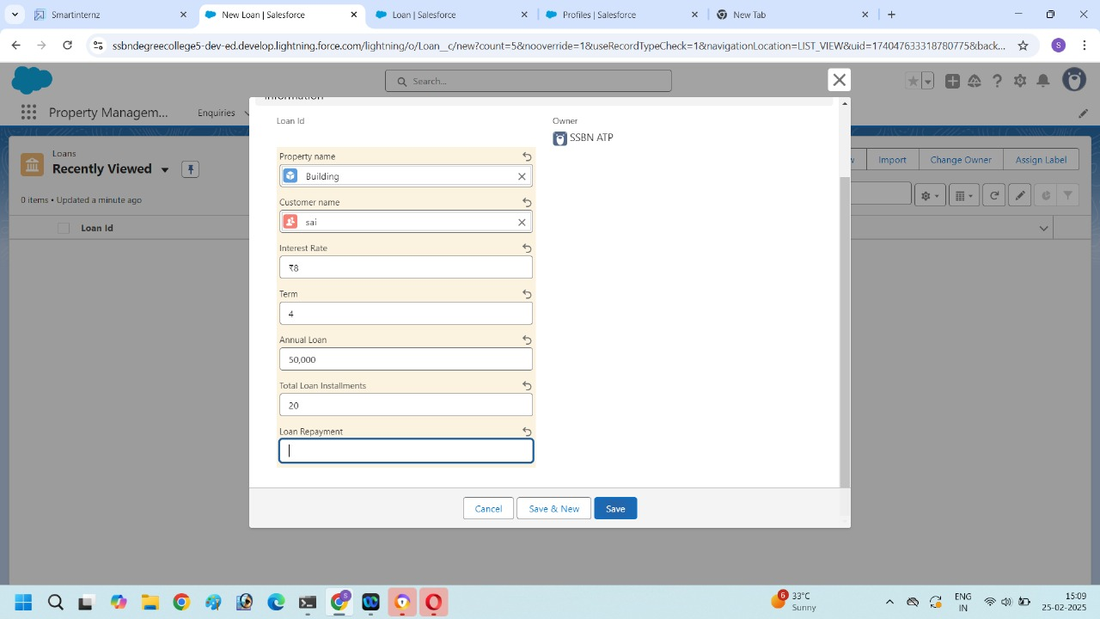

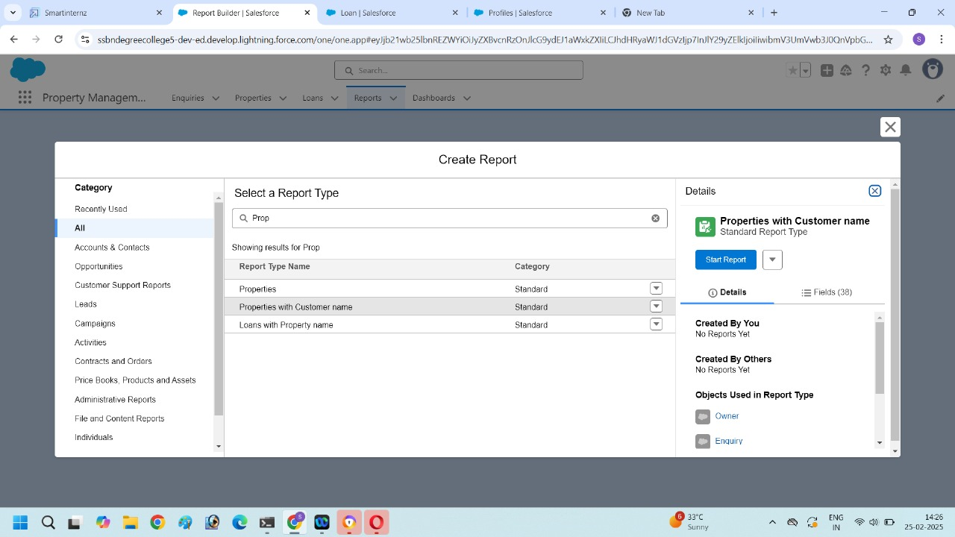

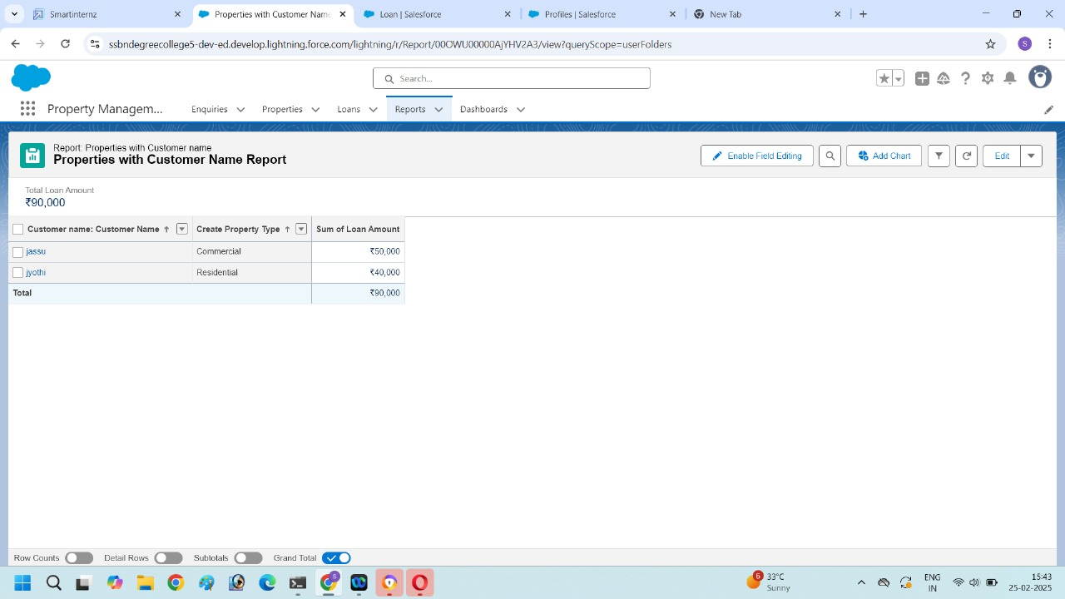

**Dashboards:**

1.Go to dashboards object then click on the new dashboard.

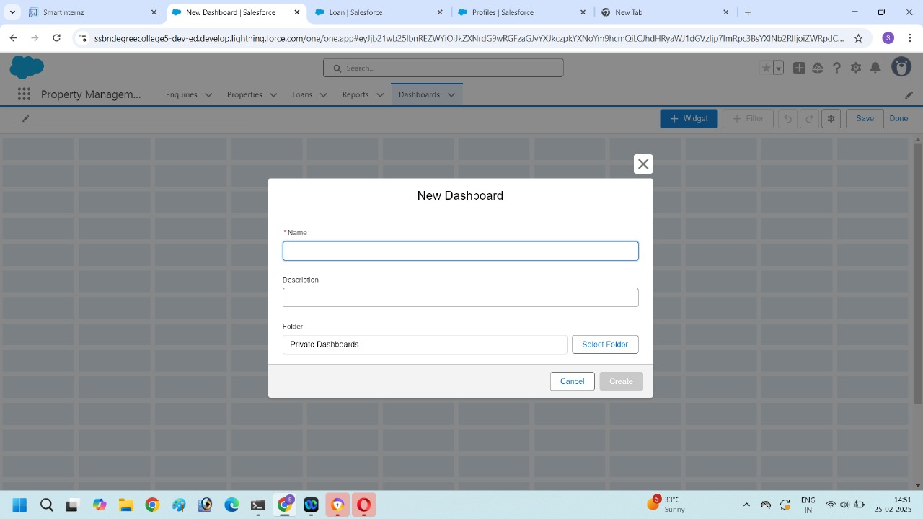

2.Name the properties with customer name Report and click create.

3.Click the + Component ,then select properties with customer name Report and click and select.

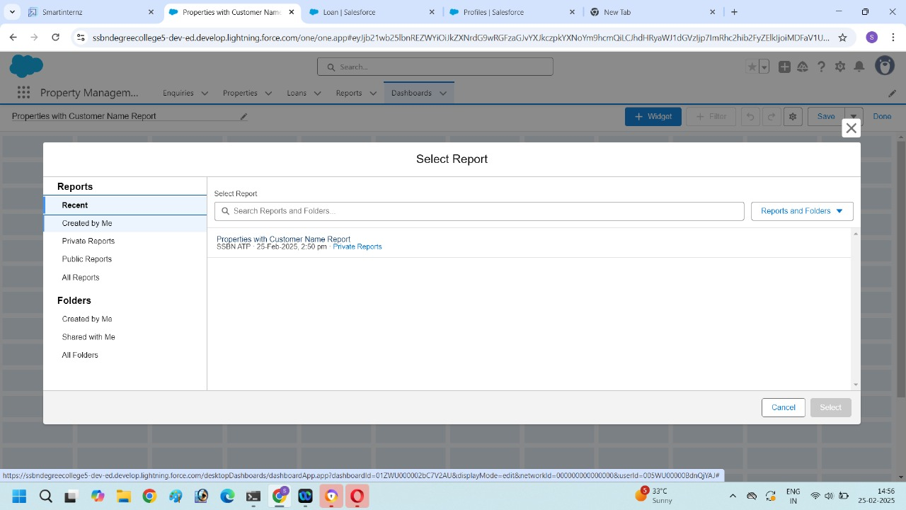

4.Select the vertical bar chart component and click Add.

5.Click save and then Done. 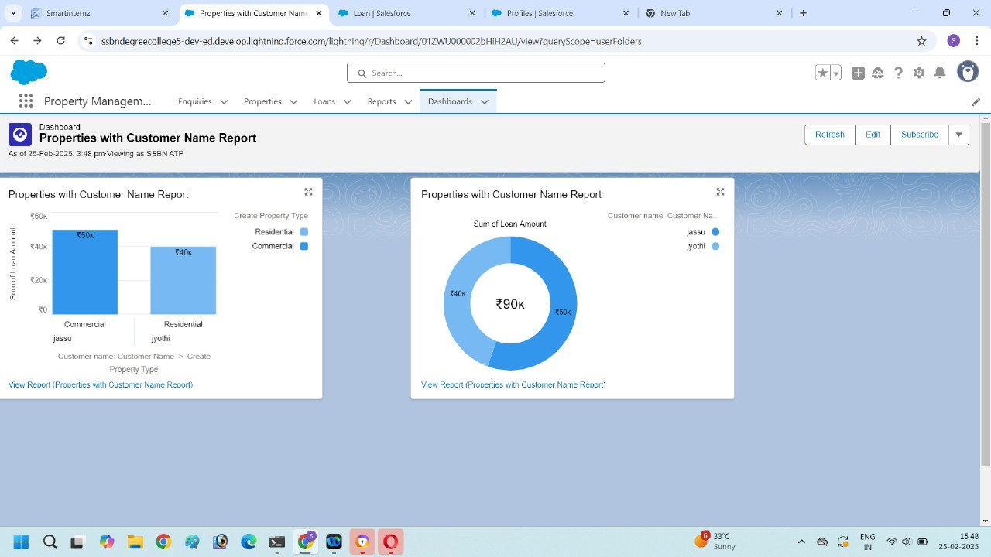

**Key Scenarios Addressed by Salesforce in the Implementation Project:**

**Scenario 1:** Streamlining tenant service request management through the portal.

**Scenario 2:** Automating property maintenance scheduling and work order assignment.

**Scenario 3:** Providing property managers with a centralized view of property and tenant information.

**Scenario 4:** Improving tenant communication and engagement through the portal.

**Scenario 5:** Generating reports and dashboards for property performance analysis.

**Conclusion:-**

The **property management application using salesforce** successfully addresses inefficiencies in real estate operations by integrating **service cloud, experience cloud, and lightning Web components**. The solution enhances **tenant service management, automates property maintenance, and improves data accuracy**. by leveraging **flows, Process builder, and reports & dashboards**, the application ensures streamlined workflows, better decision-making, and an improved tenant experience. Through thorough **testing and validation**, the system is optimized for performance, security, and usability. This project lays a strong foundation for **scalable and data-driven property management**, supporting long-term business growth.